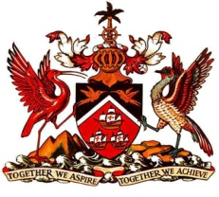

PERMANENT MISSION OF THE REPUBLIC OF TRINIDAD AND TOBAGO
TO THE OFFICE OF THE UNITED NATIONS, GENEVA
Statement by Trinidad and Tobago - Universal Periodic Review of Canada
Palais des Nations, Geneva, 26 April 2013

Mr. President,

Trinidad and Tobago welcomes the Delegation of Canada and thanks them for their informative report.

Canada boasts a strong framework for the protection and promotion of human rights, supported by its independent courts system and a network of complementary laws, policies and programmes. This framework has been strengthened since Canada’s last UPR with efforts undertaken in accordance with the various recommendations received. Among these are:

- General training for federal public servants on human rights issues;
- Progress made in the application of the analysis affecting equality between men and women across government;
- Programmes introduced in 2010-2011 dedicated to enhancing Aboriginal skills development and training that are predicted to result in new employment for an estimated 15,500 to 18,500 Aboriginal individuals annually;
- Ratification of the CRPD (Convention on the Rights of Persons with Disabilities) in March 2010.

My delegation further recommends the following measures:

1. That the Government of Canada continue in its endeavours in consistently address the skills development and training needs of Aboriginal peoples to ensure access to sustained decent work;
2. That the Government enhance its system for the protection of children by consideration of the establishment of a national Ombsudsperson for Children.

I thank you Mr. President.

37-39 RUE DE VERMONT, 1202 GENEVA, SWITZERLAND Tel: 022 918 03 80 Fax: 022 734 91 38 / 022 734 88 26
E-mail: admin@ttperm-misson.ch

